Type: Assignment
Author:- Mohammed M
Reviewed by: Minakshi Sharma
Date:05/12/2022
Version: 1.0
Duration:
Concepts:RDBMS /SQL
Complexity Category: Medium
Level: Beginner

Database structure is as shown, write the queries below:

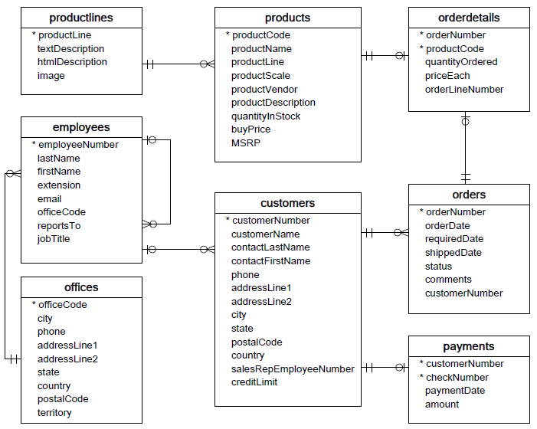

Write SQL statements for the following

1. Find the customer with the highest total order cost between 2003-02-01 to 2003-05-01.-- ~

3.Find the list of 5 customers whose total order cost lies between 2003-02-01 to 2003-05-01. If a customer had more than one order on a certain day, sum the order costs on a daily basis. Output their customer name, total cost of the credits, and the date.

4.Find the list of all customers whose total order cost lies between 2003-02-01 to 2003-05-01. If a customer had more than one order on a certain day, sum the order costs on a daily basis. Output their customer name, total cost of the credits, and the date.

5.Find the list of all customers whose total order cost lies between 2003-02-01 to 2003-05-01. If a customer has more than one order on a certain day, sum the order costs on a daily basis. Output their contactFirstName and contactLastName as contactFullName, total cost of the credits as totalCredits, and the date.

- You can download the MySQL sample database via the following link:
- Import the file to MySql workbench and write the above queries.
- Implement the same using JDBC .

Download MySQL Sample Database
Ref Notations https://stackoverflow.com/questions/1154382/anyone-have-an-erd-symbols-quick-reference

Time Estimated : 1:30 min

SELECT customers.customerNumber, customers.customerName, SUM(orderdetails.priceEach * orderdetails.quantityOrdered) AS total_order_cost FROM customers INNER JOIN orders ON customers.customerNumber = orders.customerNumber INNER JOIN orderdetails ON orders.orderNumber = orderdetails.orderNumber
WHERE
orders.orderDate BETWEEN '2003-02-01' AND '2003-05-01'
GROUP BY
customers.customerNumber
ORDER BY
total_order_cost DESC
Limit 1;

